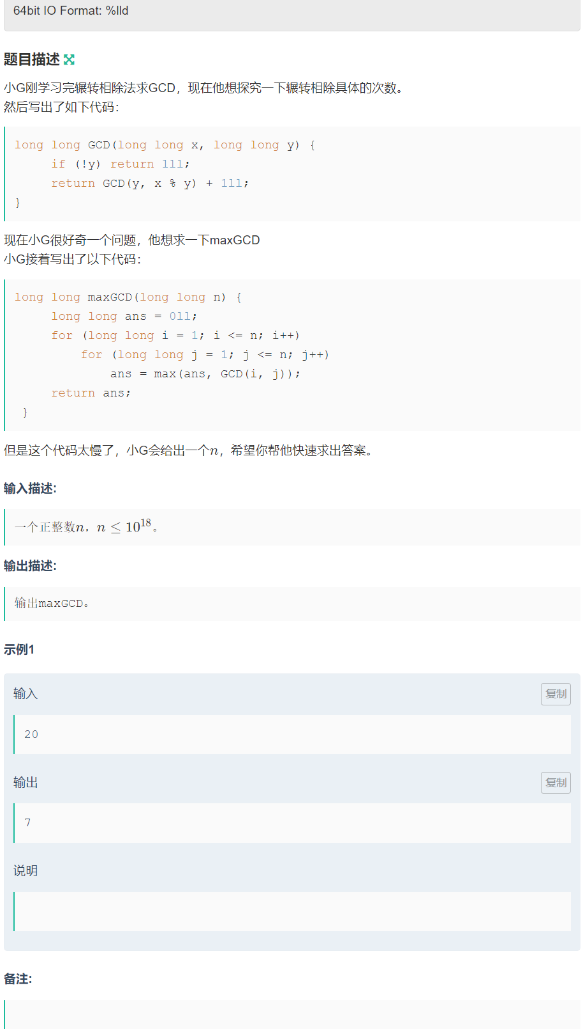

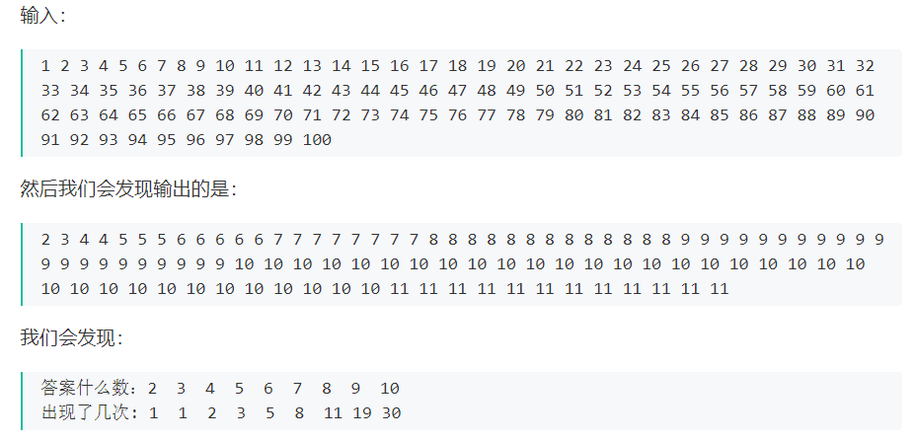

#include<bits/stdc++.h>

#define ll long long

using namespace std;

const int MAXN=200;

ll fib[MAXN];

int main()

{

ll n;

scanf("%lld",&n);

if(n==1) {cout<<"2";return 0;}

int ans=0;

fib[2]=1;

fib[3]=1;

for(int i=4;i<=76;i++) fib[i]=fib[i-1]+fib[i-2];

int f=0;

for(int i=2;i<=76;i++)

{

if(n>fib[i])

{

n-=fib[i];

ans=i;

}

else

{ ans=i;

printf("%d\n",ans);

return 0;

}

}

return 0;

}